**Assignment-6**

**EXPERIMENT – 10: Write a program to implement fractional knapsack problem using greedy approach.**

#include<stdio.h>

void knapsack(int n, float weight[], float profit[], float capacity) {

float x[20], tp = 0;

int i, j, u;

u = capacity;

for (i = 0; i < n; i++)

x[i] = 0.0;

for (i = 0; i < n; i++) {

if (weight[i] > u)

break;

else {

x[i] = 1.0;

tp = tp + profit[i];

u = u - weight[i];

}

}

if (i < n)

x[i] = u / weight[i];

tp = tp + (x[i] * profit[i]);

printf("\nThe result vector is:- ");

for (i = 0; i < n; i++)

printf("%f ", x[i]);

printf("\nMaximum profit is:- %f", tp);

}

int main() {

float weight[20], profit[20], capacity;

int num, i, j;

float ratio[20], temp;

printf("\nEnter the no. of objects:- ");

scanf("%d", &num);

printf("\nEnter the wts and profits of each object:-\n");

for (i = 0; i < num; i++) {

scanf("%f %f", &weight[i], &profit[i]);

}

printf("\nEnter the capacity of knapsack:- ");

scanf("%f", &capacity);

for (i = 0; i < num; i++) {

ratio[i] = profit[i] / weight[i];

}

for (i = 0; i < num; i++) {

for (j = i + 1; j < num; j++) {

if (ratio[i] < ratio[j]) {

temp = ratio[j];

ratio[j] = ratio[i];

ratio[i] = temp;

temp = weight[j];

weight[j] = weight[i];

weight[i] = temp;

temp = profit[j];

profit[j] = profit[i];

profit[i] = temp;

}

}

}

knapsack(num, weight, profit, capacity);

return(0);

}

**OUTPUT-**

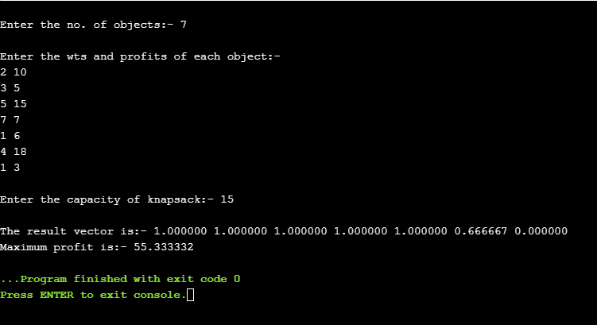

**EXPERIMENT – 11: Write a program to implement Job assignment Problem using greedy algorithm.**

def printJobScheduling(arr, t):

# length of array

n = len(arr)

for i in range(n):

for j in range(n - 1 - i):

if arr[j][2] <arr[j + 1][2]:

arr[j], arr[j + 1] = arr[j + 1], arr[j]

result = [False] * t

job = ['-1'] * t

for i in range(len(arr)):

for j in range(min(t - 1, arr[i][1] - 1), -1, -1):

# Free slot found

if result[j] is False:

result[j] = True

job[j] = arr[i][0]

break

print(job)

arr = [['a', 2, 100], # Job Array

['b', 1, 19],

['c', 2, 27],

['d', 1, 25],

['e', 3, 15]]

print("Following is maximum profit sequence of jobs")

if __name__ == '__main__':

printJobScheduling(arr, 3)

**OUTPUT-**

